**PLUGGING INTO THE FUTURE AN EXPLORATION OF ELECTRICITY CONSUMPTION PATTERNS**

**1.INTRODUCTION**

**1.1.Overview :**

Whereas electricity consumption represents the amount of electrical energy that has been consumed over a specific time, in units of Wh (or kWh), electricity demand represents that rate at which electrical energy is consumed for a needed output rating, in units of W (or kW).

**1.2. Purpose**

Heating and cooling our homes, lighting office buildings, driving cars and moving freight, and manufacturing the product we rely on in our daily lives are all function that require energy

**2. PROBLEM DEFINITION & DESIGN THINKING**

**2.1 Empathy map :**

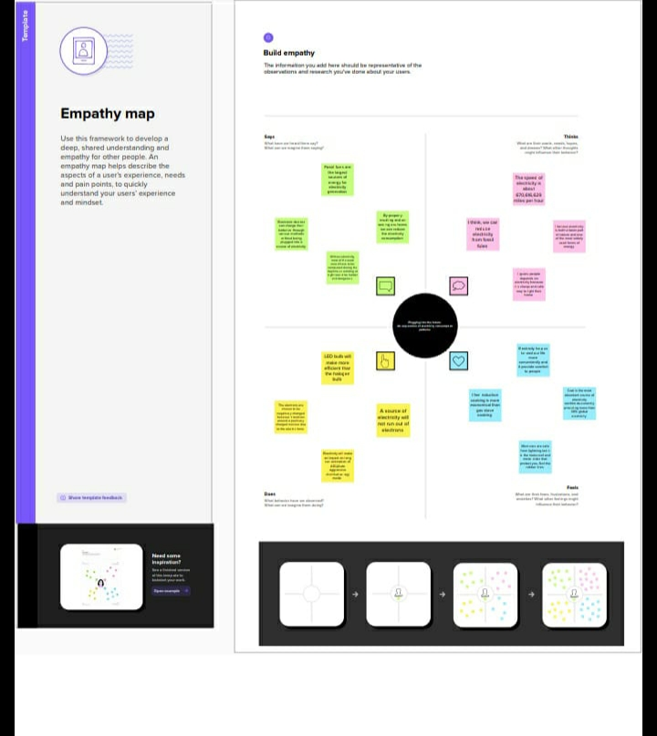

**2.2 Ideation and Brainstorming map:**

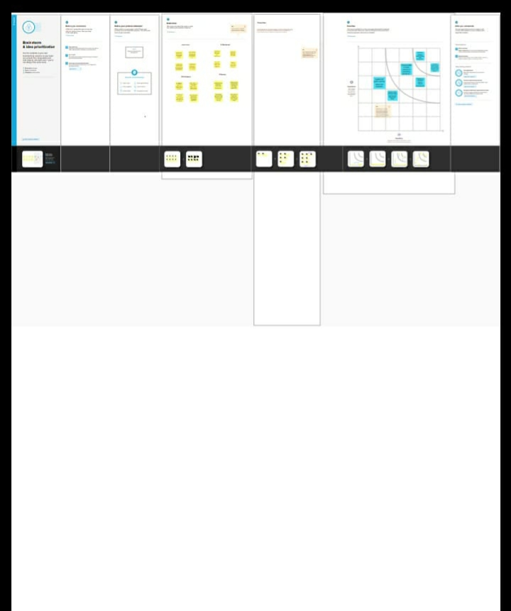

**3. RESULT:**

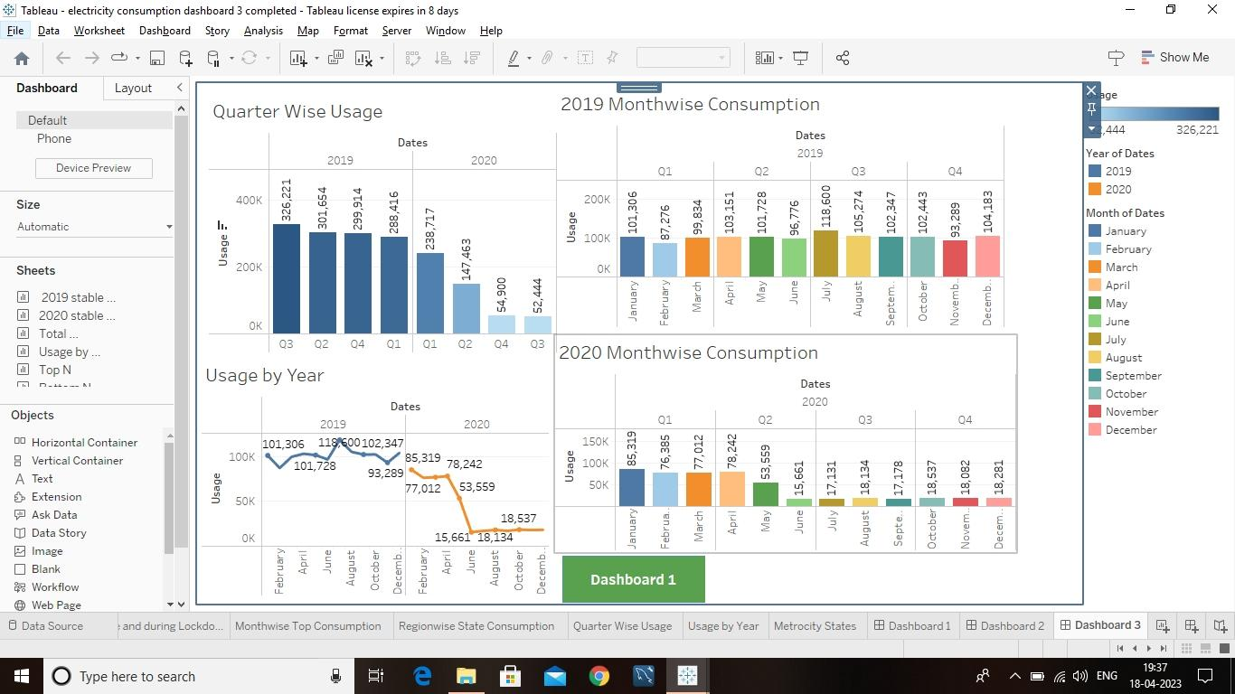

**4. ADVANTAGES & DISADVANTAGES**

**4.1.Advantages :**

* Lower maintenance cost
* More efficient
* No tailpipe emission
* It doesn’t require as many employees
* Hydroelectric station are inexpensive to operate
* A Station can operate and run for long periods of time
* Makes barely any pollution compare to other ways of creative or generating electricity.

**4.2.Disadvantages :**

* Loss of fish species
* Sometimes messes up wildlife
* Dependent on precipitation
* Cost for construction
* Change in river or stream quality
* Hydroelectric natural seasonal changes in river and ecosystems can be destroyed.

**5.APPLICATIONS**

* Healthcare
* Engineering
* Transport and communication
* Outdoors
* Household
* Commercial
* Office

**6. CONCLUSION**

Energy conservation, in addition to lowering energy cost, can benefit the environment in a variety of ways. For starters, energy conservation can protect the environment by reducing resource consumption and carbon-di-oxide emissions. Following that, energy conservation can reduce the need for new power plants.

**7.FUTURE SCOPE**

The ever-expanding industrialization and urbanization will primarily drive the energy demand that is forecasted to reach 405 gigawatts of renewable energy capacity by 2030.